Certificate of Authorization (COA) Application
DJI Matrice 300 RTK
WireGrass Gravel Pit, Alabama

GEOG 892 – Geospatial Applications for Unmanned Aerial Systems
Pennsylvania State University
Instructor: Dr. Qassim Abdullah

Submitted by:
Nicholas Dillman
February 28, 2026

Table of Contents
- Introduction and Purpose of Operation
- Applicant Contact Information
- Aircraft system
- Communications
- Ground Control Station
- Concept of Operations, Emergency Procedures, and Risk Mitigation
- Flight Operations Area and Time
- Launch and Recovery Procedures
- Lost Communications Procedures
- Lost Link Mission Procedures
- Operator (Pilot) and Visual Observers

Introduction and Purpose of Operation
The Alabama Department of Environmental Management (ADEM) proposes to conduct unmanned aircraft system (UAS) operations at the WireGrass Gravel Pit site located in Alabama. The purpose of this operation is to collect high-resolution aerial imagery to support environmental disturbance mapping and terrain-related environmental analysis. The proposed mission will utilize a DJI Matrice 300 RTK multirotor aircraft equipped with a high-resolution RGB imaging sensor.
Imagery collected during the mission will be processed using photogrammetric software to generate orthomosaic imagery and digital surface models (DSM). These products will be used to perform surface classification of disturbed and stable terrain conditions across the gravel pit site. Classification results will identify areas of bare soil, gravel or aggregate material, vegetated surfaces, and heavily disturbed terrain. The final outputs will support environmental monitoring and provide insight into disturbance intensity and terrain risk patterns within the study area.
All operations will be conducted below 400 feet above ground level (AGL) in accordance with FAA small UAS operational guidelines. Flights will occur during daylight hours under visual meteorological conditions (VMC). The aircraft will follow automated waypoint grid patterns designed to achieve sufficient image overlap required for accurate aerial triangulation and terrain modeling.

Applicant Contact Information
Public Agency Represented:
Alabama Department of Environmental Management (ADEM)

Point of Contact:
Nicholas Dillman
Conshohocken, PA, USA
Phone: 610-533-4269
Email: npd5229@psu.edu

333 Exemption Number: Not Applicable

Aircraft System

3.1 Aircraft Description
Aircraft Make and Model: DJI Matrice 300 RTK
Aircraft Type: Multirotor (Vertical Takeoff and Landing)

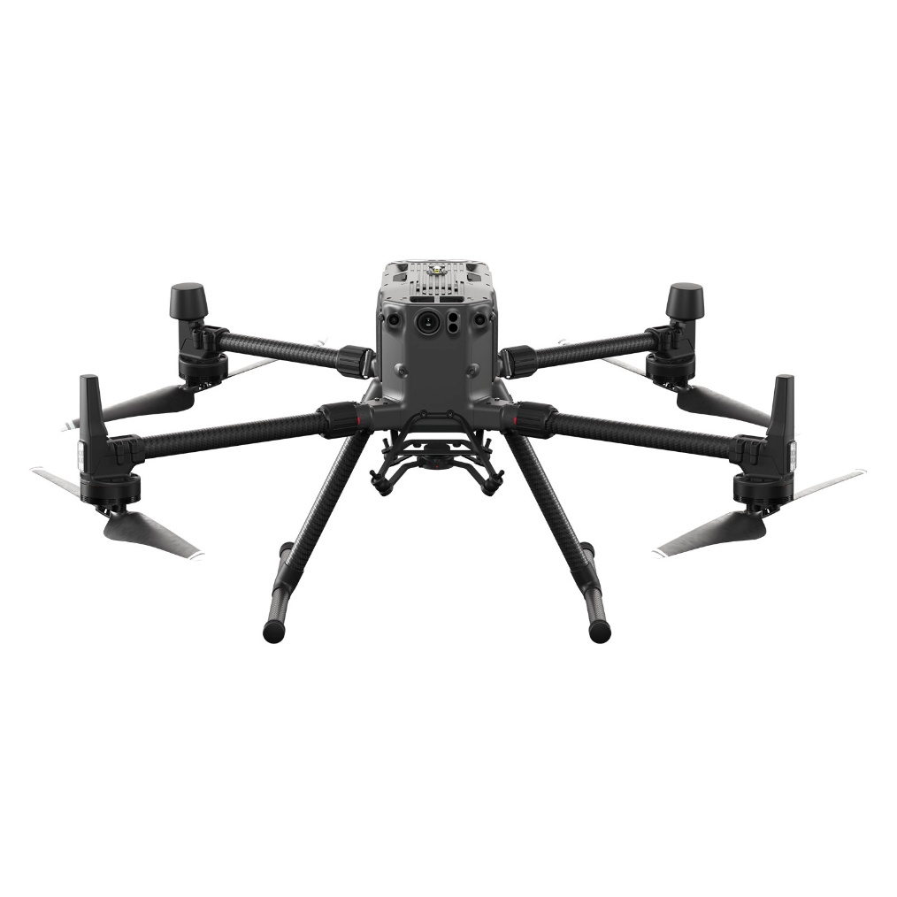
Figure 1: DJI Matrice 300 RTK UAS used for the proposed environmental monitoring mission.

3.2 Airframe and Dimensions
- Unfolded (propellers excluded): 810 x 670 x 430 mm
- Folded (propellers included): 430 x 420 x 430 mm
- Diagonal wheelbase: 895 mm
The aircraft utilizes a quad-rotor multirotor airframe with foldable arms designed for rapid field deployment and transportation.

3.3 Power Source
The aircraft is powered by dual TB60 intelligent lithium-ion flight batteries, providing electrical power for propulsion and avionics systems.

3.4 Weight (Gross Takeoff Weight)
- Weight without batteries: ≈ 3.6 kg
- Weight with batteries: ≈ 6.3 kg
- Maximum takeoff weight: 9 kg
The aircraft’s payload capacity allows integration of high-resolution imaging sensors for mapping and monitoring missions.

3.5 Avionics
The aircraft includes several onboard avionics and navigation systems:
- Multi-constellation GNSS (GPS, GLONASS, Galileo, BeiDou)
- Integrated Real-Time Kinematic (RTK) positioning module
- Dual Inertial Measurement Units (IMUs)
- Redundant compass systems
- ADS-B In (AirSense) aircraft awareness system
- Six-direction obstacle sensing and avoidance systems
These systems improve aircraft navigation accuracy and enhance operational safety during flight operations.

3.6 Performance Characteristics
- Maximum endurance: Up to 55 minutes (under ideal conditions + no payload)
- Maximum speed: 23 m/s (~ 51mph)
- Maximum ascent speed: 6 m/s
- Maximum descent speed: 5 m/s vertical
- Service ceiling: up to ~ 7000 m above sea level depending on propeller configuration

3.7 Environmental Performance
Ingress protection rating: IP45
Operating temperature: −20°C to 50°C
Maximum wind resistance: 15 m/s
The aircraft’s environmental tolerances allow operations in a variety of weather conditions while maintaining stable flight performance.

3.8 Airworthiness Statement
The DJI Matrice 300 RTK is commercially manufactured and maintained in accordance with manufacturer guidelines. Pre-flight inspections are conducted prior to each operation. Firmware updates, maintenance logs, and battery cycle records are documented and retained. The aircraft is operated strictly within manufacturer performance limits and FAA operational requirements.

Communications

4.1 Pilot to Aircraft
- Transmission system: DJI OcuSync Enterprise
- Operating frequencies: 2.4 GHz and 5.8 GHz
- Maximum transmission distance: 15 km (FCC unobstructed)

Communication between the Remote Pilot in Command and the aircraft is maintained through the DJI OcuSync Enterprise transmission system. The system operates on 2.4 GHz and 5.8 GHz frequency bands and provides secure command-and-control and telemetry communication between the aircraft and the ground control station.

4.2 Pilot to Visual Observers
Communication between the Remote Pilot in Command and visual observers will be maintained through direct voice communication. When necessary, handheld radios or cellular phones will be used as secondary communication systems.

4.3 Communication Within the Airspace
Prior to each flight operation, sectional charts will be reviewed to determine airspace classification and nearby aviation activity. If operations occur near uncontrolled airports, the appropriate Common Traffic Advisory Frequency (CTAF) will be monitored.

4.4 Video and Data Transmission
Live video and telemetry data from the aircraft sensor payload will be transmitted to the ground control station using the DJI OcuSync Enterprise transmission system.

4.5 Backup Communication
Backup communication methods include handheld radios and cellular phone communication between crew members.

Ground Control Station

5.1 Description
The Ground Control Station (GCS) used for this operation consists of the DJI Smart Controller Enterprise, which provides the command-and-control interface for operating the DJI Matrice 300 RTK aircraft. The controller includes an integrated high-brightness display and telemetry monitoring system that allows the remote pilot to monitor aircraft position, altitude, battery status, and mission parameters in real time.
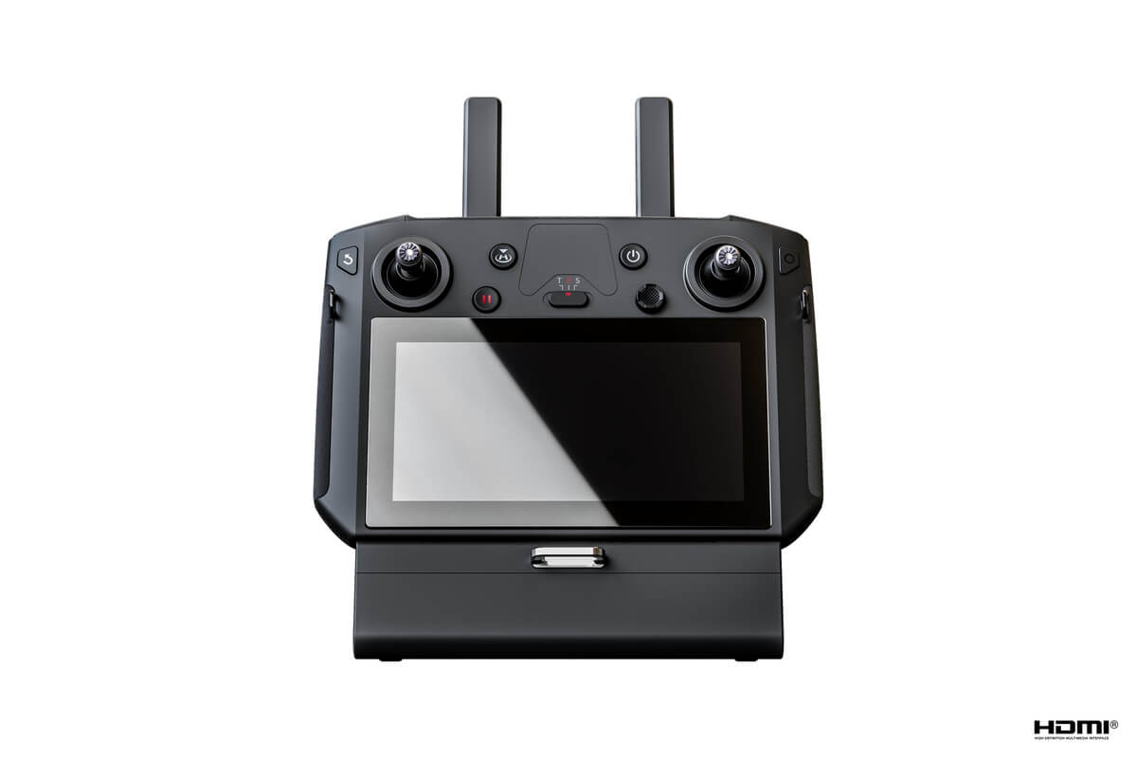
Figure 2: DJI Smart Controller Enterprise used as the ground control station for the Matrice 300 RTK aircraft.

5.2 Capabilities
The ground control station provides the remote pilot with:
- Real-time telemetry monitoring
- Aircraft position and altitude information
- Battery status monitoring
- Mission planning capability
- Emergency return-to-home activation

5.3 Setup and Operations
Prior to each mission, the ground control station will be configured and tested to ensure proper communication with the aircraft. Setup procedures include verifying controller battery levels, confirming aircraft communication link status, verifying GNSS signal reception, and reviewing mission flight parameters.

5.4 Frequency Management
Communication between the ground control station and aircraft is maintained through the DJI OcuSync Enterprise transmission system, which automatically manages frequency selection to minimize signal interference during operations.
The system operates on 2.4 GHz and 5.8 GHz frequency bands, which are approved for use under FCC regulations.

5.5 FCC Approved Equipment
The communication equipment used by the DJI Matrice 300 RTK and the DJI Smart Controller Enterprise operates on FCC-approved transmission frequencies, ensuring compliance with U.S. communications regulations.

5.6 Operational Range
Under unobstructed conditions, the communication system supports a maximum transmission range of approximately 15 km (9.3 miles) under FCC standards. However, operational flight distances during the proposed mission will be significantly shorter to maintain safe aircraft control and visual situational awareness.

Concept of Operations (ConOps), Emergency Procedures, and Risk Mitigation

6.1 Concept of Operations
The proposed mission will follow automated grid flight paths to collect high-overlap imagery suitable for photogrammetric processing. The imagery will be used to generate orthomosaic imagery and digital surface models to support environmental disturbance classification.

6.2 Hazard Identification
Potential hazards include:
- Human factors
- Machine malfunction
- Environmental conditions such as wind
- Operational coordination issues
- Mission-specific hazards such as terrain obstacles

6.3 Risk Assessment
Weather conditions represent a significant operational risk. Flights will be postponed if wind speeds exceed safe operating limits or if precipitation occurs.

6.4 Risk Mitigation Measures
Risk Mitigation measures include pre-flight inspections, visual observer support when necessary, defined safety buffer zones, and emergency return-to-home procedures.

Flight Operations Area and Time

7.1 COA Location
The proposed operations will occur at the WireGrass Gravel Pit site. The boundary of the operational area and launch location are indicated. The operational area covers approximately 0.25 km² of disturbed terrain within the gravel pit boundary.
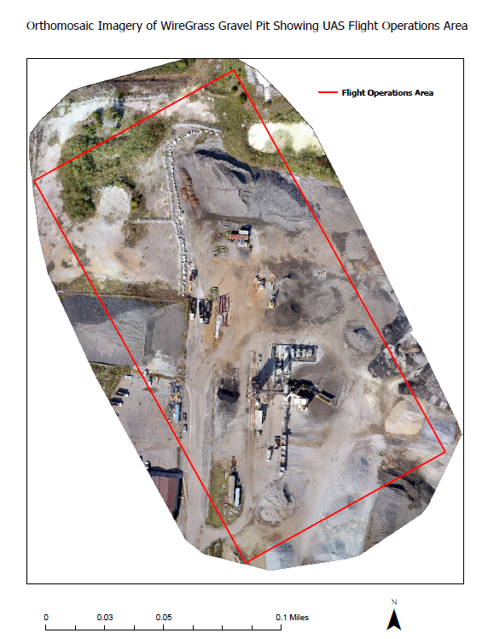
Figure 3: Proposed UAS flight operations area at the WireGrass Gravel Pit site. The boundary of the operational area and launch location are indicated.

7.2 Boundary Coordinates
Approximate operational boundaries include the following coordinates:
Upper Left: 34.78472° N, 86.64026° W
Upper Right: 34.78544° N, 86.63881° W
Lower Right: 34.78309° N, 86.63717° W
Lower Left: 34.78240° N, 86.63866° W

7.3 Airspace Classification
The proposed flight area is located within Class G airspace. Operations will occur below 400 feet AGL in accordance with the FAA small UAS operating limitations.
Prior to flight planning, the airspace surrounding the project area was evaluated using FAA sectional charts to determine the applicable airspace classification and identify nearby aviation infrastructure.
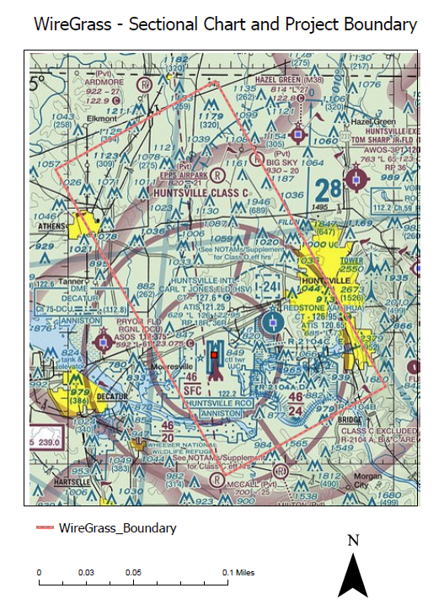
Figure 4: VFR sectional chart showing the airspace classification surrounding the proposed Wiregrass Gravel Pit UAS operations area. The red boundary indicates the approximate project location relative to surrounding aviation features and airspace classifications.
As shown in Figure 4, the proposed Wiregrass Gravel Pit operations area is located within uncontrolled Class G airspace, which minimizes interaction with controlled airspace operations. Operating within Class G airspace allows the UAS mission to be conducted without the need for additional airspace authorization from air traffic control, provided that all FAA Part 107 operational requirements are followed. Nearby aviation features and airports were also reviewed to ensure the planned mission maintains safe separation from other airspace users.

7.4 Planned Nominal Flight Operations
Flights will occur between 200 and 400 feet above ground level using automated waypoint grid missions designed to achieve sufficient image overlap for photogrammetric processing.

Launch and Recovery Procedures
The DJI Matrice 300 RTK utilizes a vertical takeoff and landing (VTOL) configuration. Aircraft launch and recovery will occur from a flat gravel staging area within the designated operational boundary.
Prior to launch, a complete pre-flight checklist will be conducted including aircraft inspection, battery verification, GNSS signal confirmation, and communication link verification with the ground control station.
Takeoff will occur vertically under manual pilot control before transitioning to automated waypoint mission operations. Upon mission completion, the aircraft will return to the launch location and perform a controlled vertical landing under pilot supervision.
Weather limitations for safe operation include:
• Maximum sustained wind speeds of approximately 20 mph
• No precipitation conditions
• Adequate visibility for maintaining visual line-of-sight.
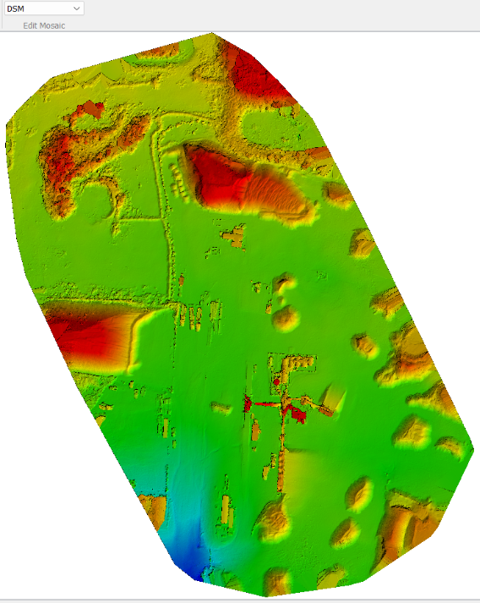
Figure 5: the Digital Surface Model (DSM) highlights terrain variation across the Wiregrass Gravel Pit and provides useful information for identifying relatively flat areas suitable for UAS launch and recovery operations.
The Digital Surface Model (DSM) was examined to evaluate terrain conditions within the proposed flight operations area. The elevation visualization highlights variations in surface height across the gravel pit, with elevated stockpiles and berms visible as red and orange areas and lower terrain represented by green and blue tones. Several relatively flat gravel surfaces are visible throughout the central portion of the site, indicating multiple suitable locations for safe UAS launch and recovery. These areas provide open space with minimal vertical obstacles while maintaining clear line-of-sight to the entire flight operations area.

Lost Communications Procedures
In the event of communication loss between the aircraft and ground control station, the aircraft will automatically initiate the Return-to-Home (RTH) procedure and return to the designated launch location.

Lost Link Mission Procedures
If communication between the aircraft and ground control station is interrupted, the aircraft will automatically initiate the programmed Return-to-Home (RTH) procedure. The aircraft will ascend to a predetermined safe altitude and navigate to the designated launch point.
Potential lost link scenarios include:
• Internal navigation system failure
• Control system malfunction
• Communication signal interruption
• Low battery condition
If communication is re-established during the return sequence, the remote pilot may resume manual control of the aircraft. If the communication link cannot be re-established, the aircraft will continue the automated return-to-home procedure and perform a safe landing at the designated recovery point.
The remote pilot will monitor aircraft telemetry and maintain communication with visual observers during the event.

Operator (Pilot) and Visual Observers
All flight operations will be conducted by a Remote Pilot in Command (RPIC) holding a valid FAA Part 107 Remote Pilot Certificate. The RPIC is responsible for aircraft operation, mission planning, and compliance with FAA regulations.
Visual observers may be used during operations to assist with maintaining situational awareness and monitoring surrounding airspace. Communication between the pilot and observers will be maintained through direct voice communication.
All personnel involved in flight operations will receive training on aircraft safety procedures, emergency protocols, and operational coordination prior to mission deployment.
Only one unmanned aircraft will be operated at a time within the designated operational area.

